Geo772-F2026: Individual Research Paper

Your Individual Research Paper must be formatted as follows:
- Times New Roman 12pt font
- 1.5 line spacing except Abstract, Table and Figure captions are single spaced
- The References are also single spaced
- Provide a Word Count on the Title Page
- Use Full Justification (see below)
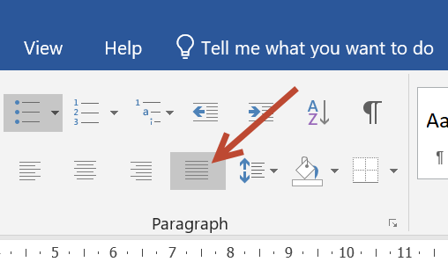

Note: Figures and Tables must be inserted as appropriate in the paper.

The following sections are mandatory (you can include other sections if you deem them appropriate and necessary):

Title/Cover Page
Contains the paper's title, the author's name, e-mail, and the day's date. A Word Count also appears here.

Abstract
Approximately 250 words, the abstract generally provides a broad overview. It describes the main theme/findings of the paper. It includes the research question posed, its significance, the methodology and conclusions. References are never listed in an abstract. Take some time and put a lot of thought into composing the abstract. It is the first part of the paper your instructor will read.

Keywords

Five to six keywords that are important to the paper. These appear directly after the Abstract.

Introduction
A good introduction states the main research problem and argument. What precisely are you studying and why is it important? How original is it? Will it fill a gap in other studies? Never provide a lengthy justification for your topic before it has been explicitly stated.
A subsection of the Introduction is the Study Area.

Literature Review (you have already completed this)
The research process uncovers what other authors have written about your topic. Your paper should include a discussion or review of what is known about the subject and how that knowledge was acquired. Once you provide the general and specific context of existing knowledge, you can build upon it.

Methodology
Discuss your research methodology. Did you employ qualitative or quantitative research methods? Did you administer a questionnaire or interview people? Any field work conducted? How did you collect data? Did you utilize other libraries or archives?

Analysis/Discussion
This is generally the longest part of the paper. It is where the author builds the argument. It contains most of the references and analysis. This section should focus on a rational development of the paper with clear reasoning and solid argumentation at all points.

Conclusion
After spending a great deal of time and energy introducing and arguing the points in the main body of the paper, the conclusion brings everything together and underscores what it all means. A stimulating/informative conclusion leaves the reader informed about what the paper was about. It makes sense when read independently from the rest of the paper.

References

All work that is cited or was utilized to write your research paper. Listed alphabetically by the authors last name. Consult the Literature Review Referencing Example for information on Referencing.

If you used certain software it must also be referenced. For example, if you utilized ArcGIS Pro, the in-text reference would be (ESRI, 2026) and would appear in the References as:

ESRI. 2026. ArcGIS Pro. Environmental Systems Research Institute. Redlands, California. https://www.esri.com/en-us/home

The above information is adapted from:
https://libguides.bc.edu/edpaper/sections

